**SIT725 Task 2.2P  
Krizza Lou Isidro   
S222509548**

**Intro to Programming**

Link of Github:[**https://github.com/kooksyyy/SIT725-2024-T1-Prac1/tree/master**](https://github.com/kooksyyy/SIT725-2024-T1-Prac1/tree/master)

**Screenshots of running code:  
  
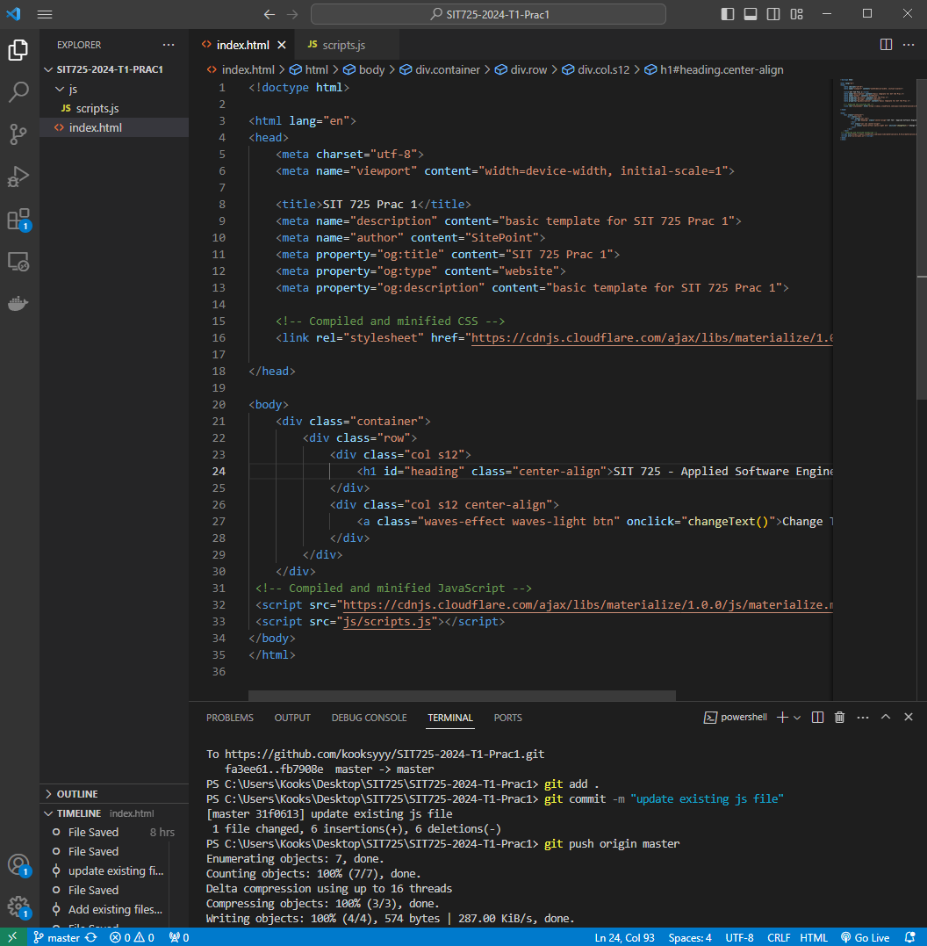  
HTML Source code**

**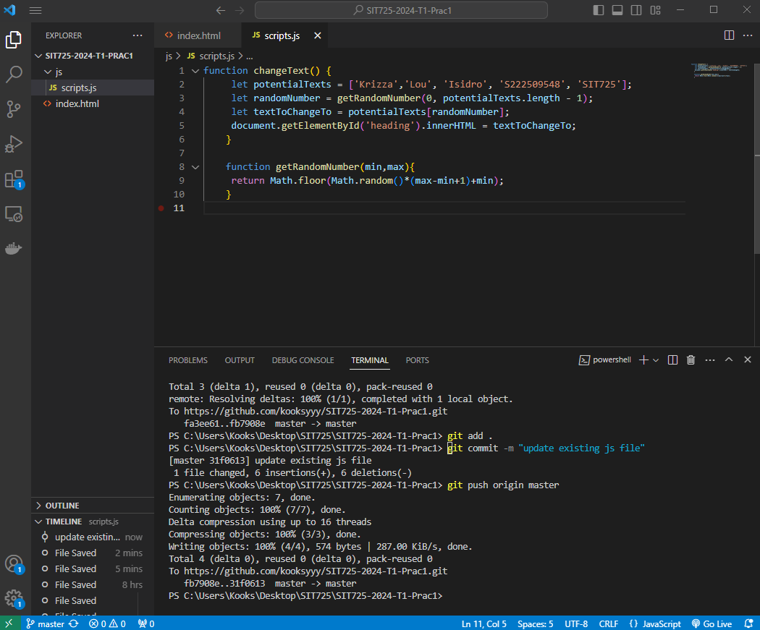  
JS Source code**

**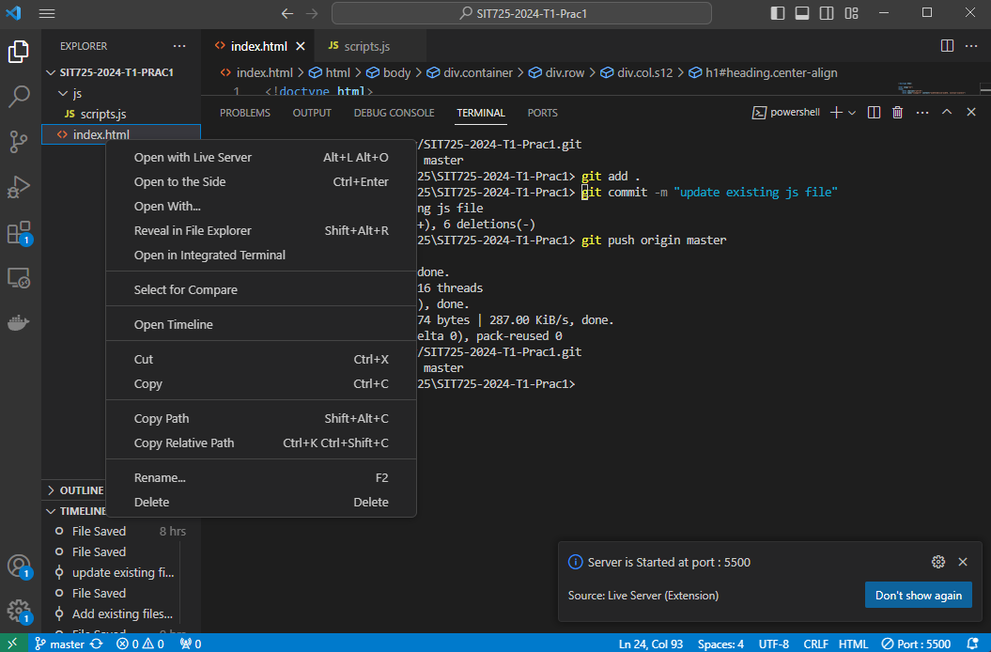  
Live Server**

**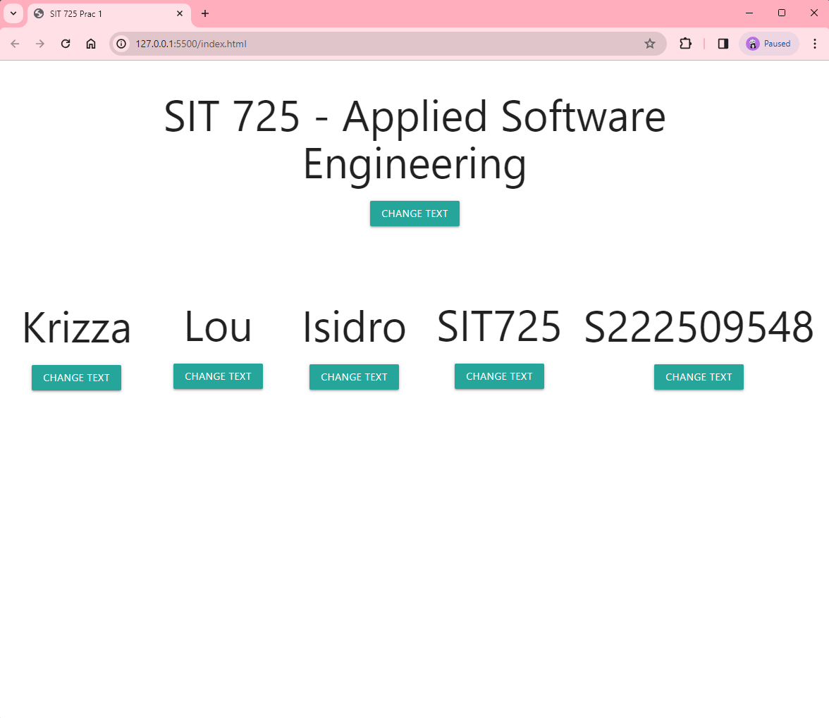  
Output**